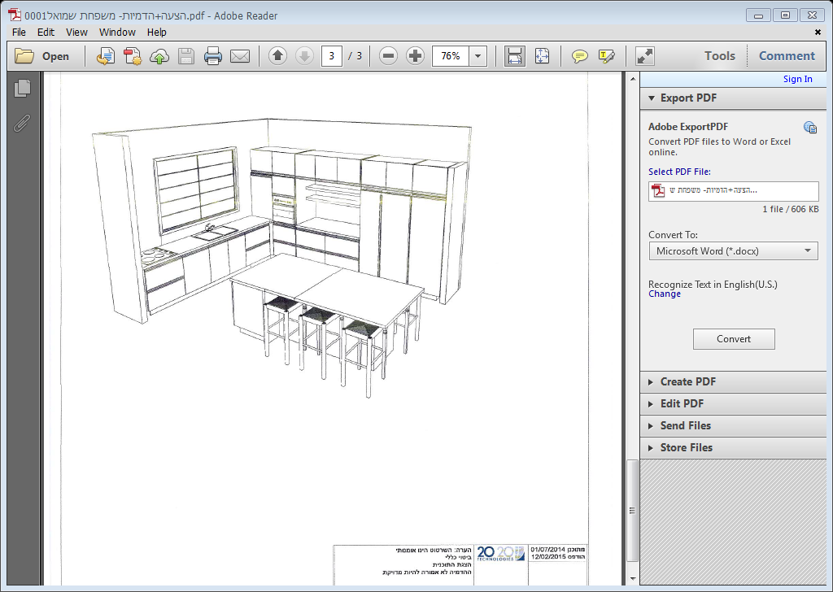
2
2
2
1
1
2
1
1
1
1
2
2
5

